**High Efficiency Video Coding**

**Introduction:**

HEVC (High-Efficiency Video Coding) is a video compression standard that was developed to provide better compression efficiency compared to previous video compression standards such as H.264/MPEG-4 AVC. HEVC was developed by the Joint Collaborative Team on Video Coding (JCT-VC), which is a group of experts from the ITU-T Video Coding Experts Group (VCEG) and the ISO/IEC Moving Picture Experts Group (MPEG).

HEVC uses advanced compression techniques such as larger block sizes, improved motion compensation, and more efficient coding of prediction residuals to achieve higher compression ratios without compromising video quality. The standard supports resolutions up to 8K and HDR (High Dynamic Range) content.

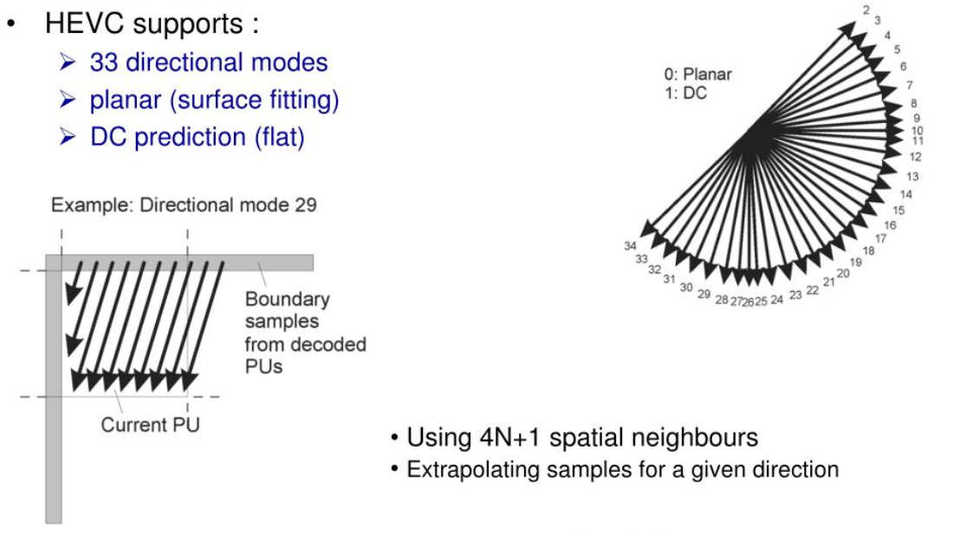

HEVC is commonly used for streaming video, video on demand (VOD), and other video applications where bandwidth and storage space are limited. It is also supported by popular devices and platforms such as iOS, Android, Windows, and macOS.

1. Larger block sizes: HEVC supports block sizes up to 64x64 pixels, which is four times larger than the maximum block size of 16x16 pixels supported by H.264. This allows for better compression of complex textures and patterns in the video.
2. Improved motion compensation: HEVC uses more accurate motion estimation and compensation techniques to predict the movement of objects in a video. This helps to reduce the amount of information that needs to be transmitted, resulting in better compression.
3. More efficient coding of prediction residuals: HEVC uses a more sophisticated approach to code the difference between the original video and the predicted video. This approach allows for better compression of fine details and textures in the video.
4. Flexible partitioning: HEVC allows for more flexible partitioning of the video into coding units, allowing for better adaptation to different video content types and resolutions.

**Some Common Resolutions:**

HEVC supports resolutions up to 8K (7680x4320 pixels) and HDR (High Dynamic Range) content, which allows for more vivid and lifelike images. However, the encoding and decoding process of HEVC is computationally complex and requires more processing power compared to H.264. As a result, hardware support is required for efficient implementation of HEVC.

HEVC is commonly used for streaming video, video on demand (VOD), and other video applications where bandwidth and storage space are limited. It is also supported by popular devices and platforms such as iOS, Android, Windows, and macOS. HEVC has become increasingly important in recent years due to the growing demand for high-quality video content on mobile devices and the internet.

**Prediction modes:**

In HEVC (High-Efficiency Video Coding), there are two types of prediction modes used for compressing video data: intra prediction and inter prediction.

1. **Intra prediction** is used to predict the value of a pixel within a block using the values of other pixels within the same block. Intra prediction is effective for compressing areas of an image that contain uniform colors or textures, where there is a high degree of correlation between adjacent pixels. In HEVC, intra prediction is applied on a block-by-block basis, with each block being predicted independently.

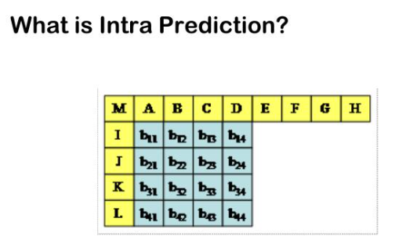

1. **Inter prediction ,** on the other hand, is used to predict the value of a pixel in a current block using the values of pixels from previously encoded frames or blocks. Inter prediction is effective for compressing areas of an image where there is a lot of motion or change between frames. In HEVC, inter prediction is applied using various block sizes and motion vectors, which indicate the displacement between the current block and the reference block.

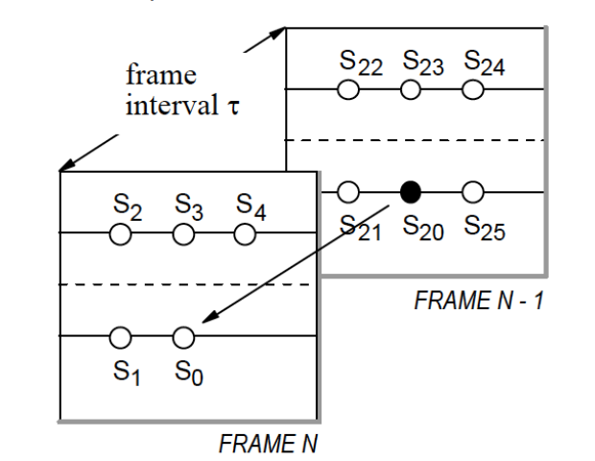

HEVC employs a hierarchical block structure for inter prediction, with larger blocks subdivided into smaller blocks for more accurate motion estimation. The motion vectors for the smaller blocks are derived from the motion vectors of the larger blocks, which helps to reduce the amount of data required for motion estimation.

Both intra and inter prediction techniques are used in HEVC to achieve high compression efficiency while maintaining high-quality video. Intra prediction is used for areas of the image that are spatially homogeneous, while inter prediction is used for areas that exhibit temporal correlation between frames.

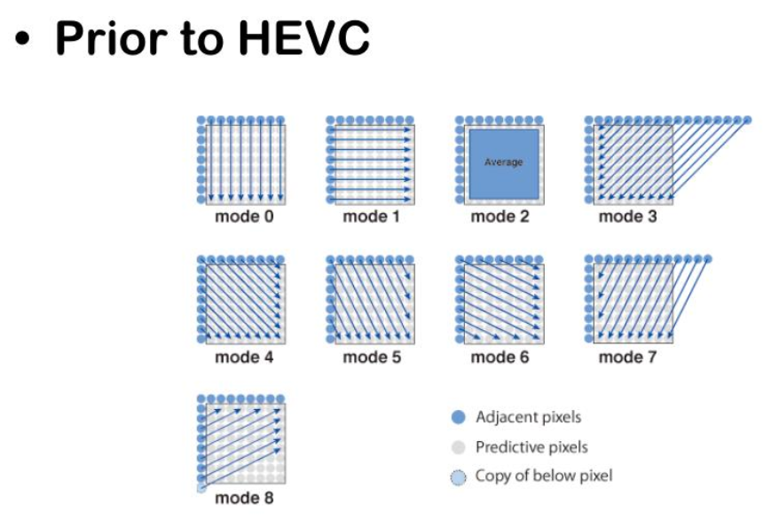

**Coding Tree:**

In HEVC (High-Efficiency Video Coding), the Coding Tree Unit (CTU) is the basic coding unit used for compression. The CTU is a rectangular block of pixels that is subdivided into smaller rectangular blocks called coding units (CUs). The size of the CTU is typically 64x64 or 128x128 pixels, and the size of the CUs can range from 8x8 to 64x64 pixels.

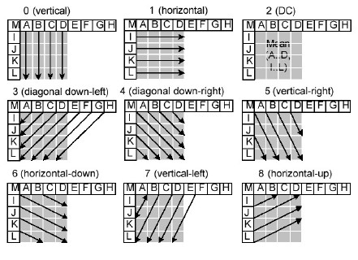

The CTU is organized in a tree-like structure called the Coding Tree, which represents the hierarchical relationships between the different sizes of CUs. The Coding Tree has four levels: the root level, the quadtree level, the binary split level, and the trinary split level.

At the root level, the CTU is split into four equal-sized quadrants. Each quadrant is then split into smaller CUs at the quadtree level, which can be either square or rectangular in shape. The quadtree level allows for more flexible partitioning of the CTU into smaller CUs, which can be used to adapt to different types of video content.

At the binary split level, each CU is split into two rectangular CUs of equal size, while at the trinary split level, each CU is split into three rectangular CUs, with the sizes of the three CUs being in a 1:2:1 ratio. The binary and trinary split levels allow for finer partitioning of the CUs, which can help to improve the compression efficiency.

HEVC also introduces a concept called the prediction unit (PU), which is used to predict the motion of objects in the video. The PU is a rectangular block of pixels that is typically smaller than the CU, and it can be located anywhere within the CU. The PU can be either inter-coded or intra-coded, depending on whether it is predicted from a previous frame or from pixels within the same frame.

**Coding Tree Structure:**

The Coding Tree structure in HEVC provides a flexible and efficient way to partition and compress video data. By allowing for different sizes and shapes of CUs, and by using both intra and inter prediction techniques, HEVC is able to achieve high compression efficiency while maintaining high video quality.

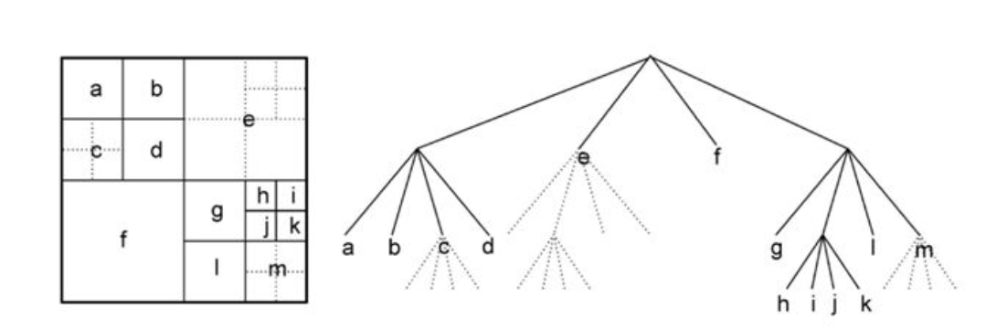

In HEVC (High-Efficiency Video Coding), there are several basic coding units that are used to partition and compress video data. These units include the Coding Tree Block (CTB), the Coding Tree Unit (CTU), the Coding Block (CB), and the Coding Unit (CU).

**Common Units:**

1. The CTB is the largest coding unit in HEVC, and it is a rectangular block of pixels that is typically 64x64 or 128x128 pixels in size. The CTB is divided into smaller CTUs, which are typically 16x16 pixels in size. Each CTU is further divided into smaller CUs, which can range in size from 8x8 to 64x64 pixels. The CTB is the highest level of the Coding Tree structure in HEVC.

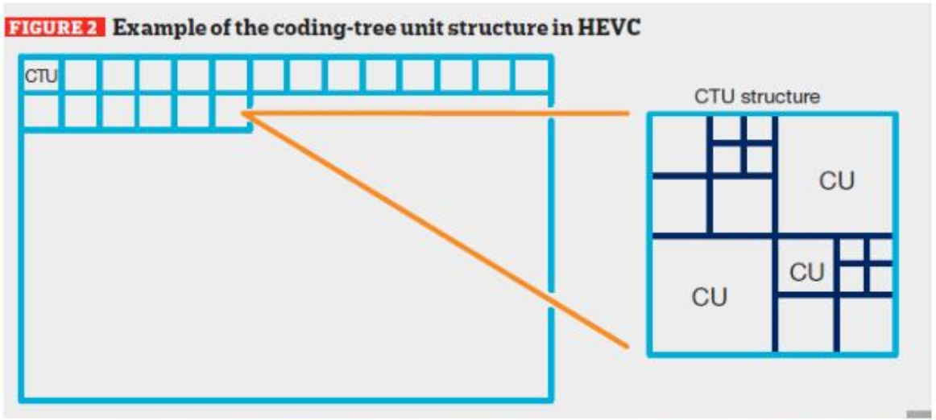

1. The CTU is a rectangular block of pixels that is typically 16x16 pixels in size, and it is the second highest level of the Coding Tree structure in HEVC. The CTU is further divided into smaller CUs, which are typically square blocks of pixels.
2. The CB is a rectangular block of pixels that is typically 16x16 pixels in size, and it is used for intra-prediction in HEVC. The CB is further divided into smaller CUs, which can range in size from 8x8 to 16x16 pixels.

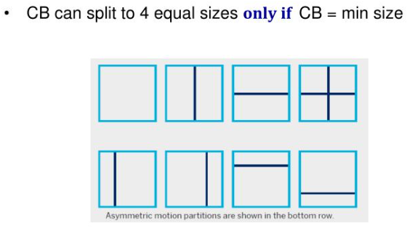

1. The CU is the smallest coding unit in HEVC, and it is a rectangular block of pixels that is typically 8x8 or 16x16 pixels in size. The CU is the basic unit of prediction in HEVC, and it can be either intra-coded or inter-coded. The intra-coded CU is predicted from pixels within the same frame, while the inter-coded CU is predicted from pixels in a previous frame.

In summary, the CTB is the largest unit used for compression in HEVC, and it is divided into smaller CTUs, which are divided into smaller CUs. The CB is a specialized unit used for intra-prediction, while the CU is the basic unit of prediction in HEVC, and it can be intra-coded or inter-coded.